Introduction
Reports can be accessed from a Project's overview (accessed from the projects menu) in the 'Summary' tab.
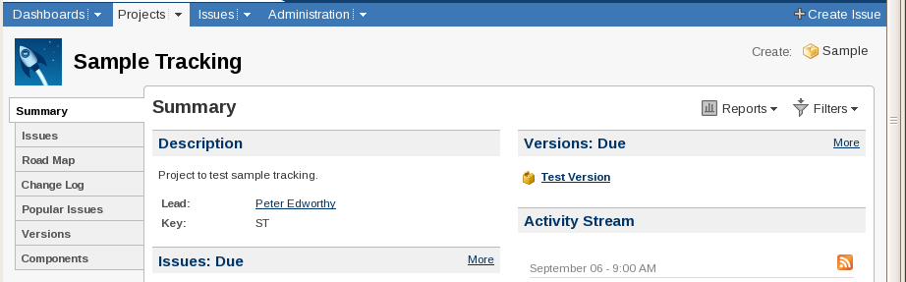
Project Summary and Reports Menu
The reports menu is in the top right hand corner of the page
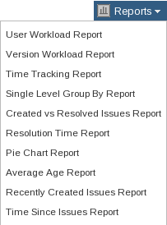
Reports drop-down menu

Note: Storing Charts and Reports
JIRA doesn't have any native way to store charts or their settings. The charts produced can be saved as images by right clicking on them and selecting 'Save Image As...' from the menu. If there is a graph that is useful to generate regularly the settings can be saved by bookmarking the page that the graph is shown on. Returning to the bookmarked page will cause the graph to be re-drawn with the current information.

Charts

Creating a Pie Chart (of the number of samples in each state)
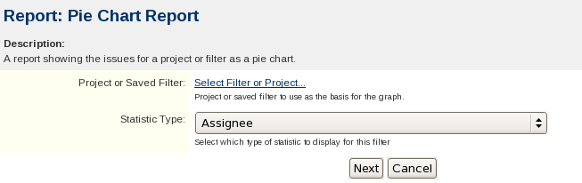
Pie Chart Creation Dialog
Project or Saved Filter:
This can be set to project (to include all the Issues and Sub-tasks in the Project), or a pre-saved filter that selects only the samples required.
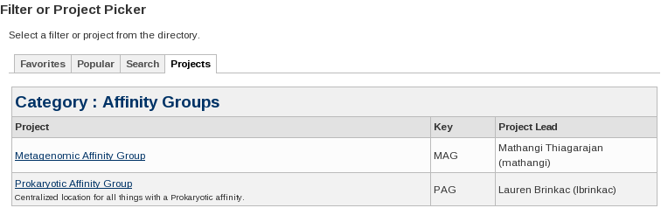
Project or Saved Filter
Statistics Type:
Set to Status

Which produces the following pie chart
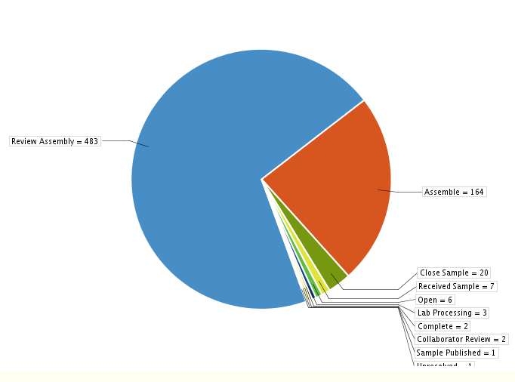
Report: Pie Chart Report, Project: Sample Tracking (Status)
A summary table is also produced
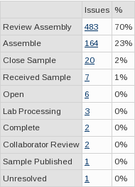
Summary for the above chart
The example table includes the extra states of Open and Complete as sub-tasks have also been included. Using a filter instead of a Project would allow Sub-tasks to be excluded.

Reports

Creating a Report (on the number of samples in each state)
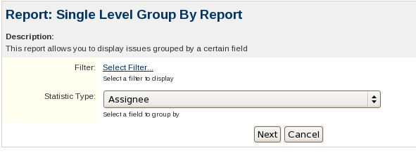
Single Level Group Report Creation Dialog
Filter:
Unlike the filter selector for Pie Charts there is no option it directly pick a project but a Filter that only selects the project can be created if needed.
Statistic Type:
Set to 'Status'
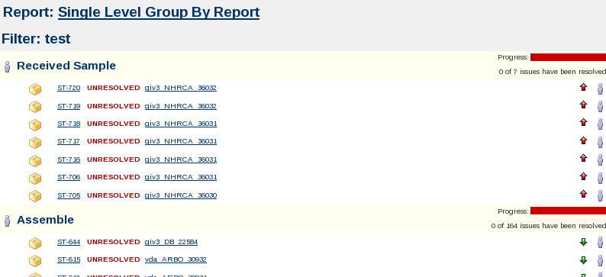
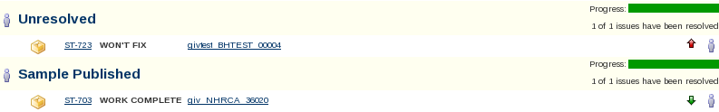
Single Level Group By Report of Samples in Sample Tracking by Status
The output of the report is somewhat verbose but it does include all of the data
Below the progress bar the total number of issues in that group is listed (7 for Received Sample). The progress bar and 'resolution' column are not very useful here as the states map to the completion or otherwise of the sample. Each step will have 100% of the samples in it mapped to the same resolution.
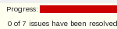
WARNING:
Unresolved in the 1st screen shot of the report is not the same as the state Unresolved in the second screen shot. Unresolved is what Atlassian have decided to print if an Issue or Sub-task has not been closed.
The group headings link to Issue Navigator with a query that will select only that group of samples.

Dashboard Gadgets

Introduction
JIRA can produce mini charts and reports for display on a user/project's dashboard (AKA Home Screen). The various charts and reports are generated by Gadgets.

Adding a Gadget (for listing the number of samples in each state)
Under the 'Dashboard' drop down select 'Manage Dashboards' to bring up the 'Manage Dashboards' page.
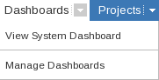
Dashboards drop-down menu
Next select 'Create new Dashboard'
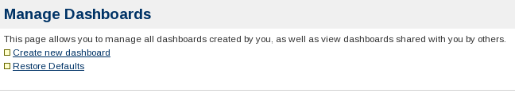
Manage Dashboards page
The only required field for creating as dashboard is name, all the others can be left blank or as their defaults.
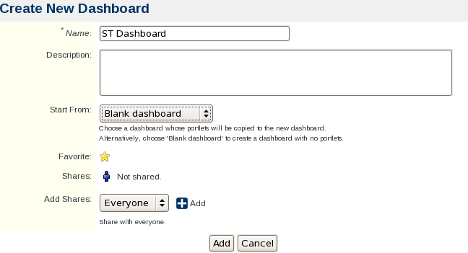
Create Dashboard form

The newly created dashboard can be accessed via its entry on the 'Manage Dashboards' page or via the Dashboards drop-down menu
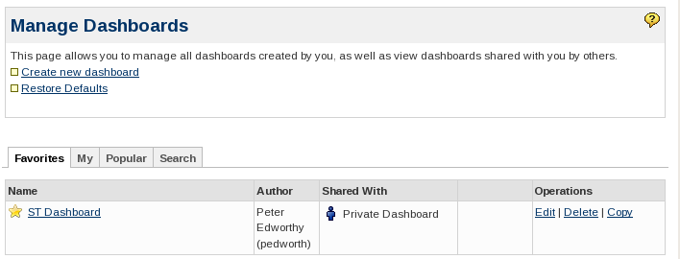
Manage Dashboards Screen, after the dashboard has been created
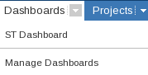
The Dashboards drop-down with the new Dashboard
The dashboard will initially contain only two dashed areas with 'Drag your gadgets here or add a New gadget' written in them. At the top there are three icons, 'Add Gadget', 'Edit Layout' and 'Tools'.
Dashboard Icons
Clicking the Add Gadget Icon, or the link in the dashed boxes, brings up the selector for Gadgets. There are a confusing number to choose between. Enter 'issue statistics' in the search box to find the gadget needed. Then click the 'Add it Now' button and then 'Finished'.

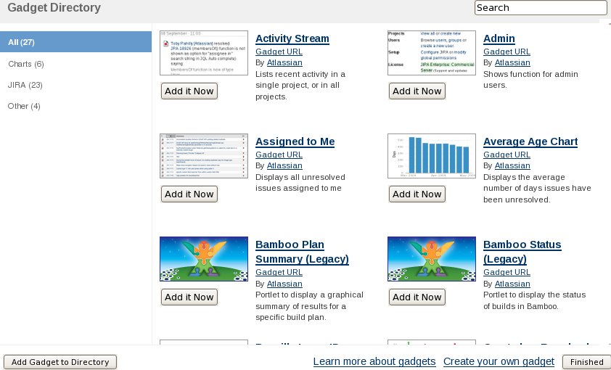
The Gadget Selector
One of the dashed boxes should have been replaced with a form titled 'Issue Statistics'.
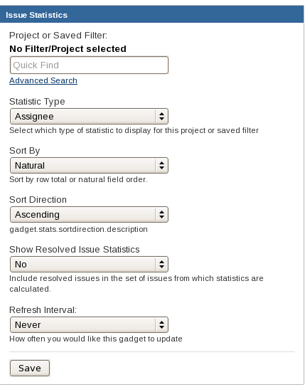
Issue Statistics
Project or Saved Filter:
Enter the name of the project or filter if known. Otherwise click 'advanced search' which opens up a window very similar to that used when setting up the 'Reports'.
Statistic Type: Status
Sort By: Natural / Total
Sort Direction: Assending/Decending
Show Resolved Issue Statistics:
Yes/No. If No is selected then the 'unresolved', 'deprecated' and 'sample published' states would not be shown.
Refresh Interval: Never/15min/30min/1hr/2hr
And click 'Save'
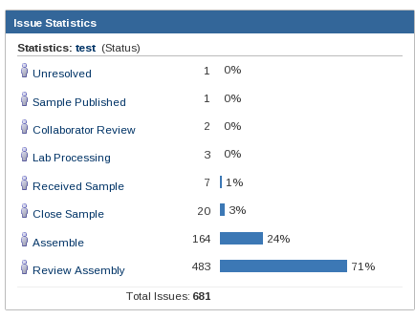
The new Gadget

